Jenna de Beer

ST10092652

NEPR7312

Portfolio of Evidence: Part One

*Activity Three*

System Issues with Script Resolution

# Disk Space Cleanup

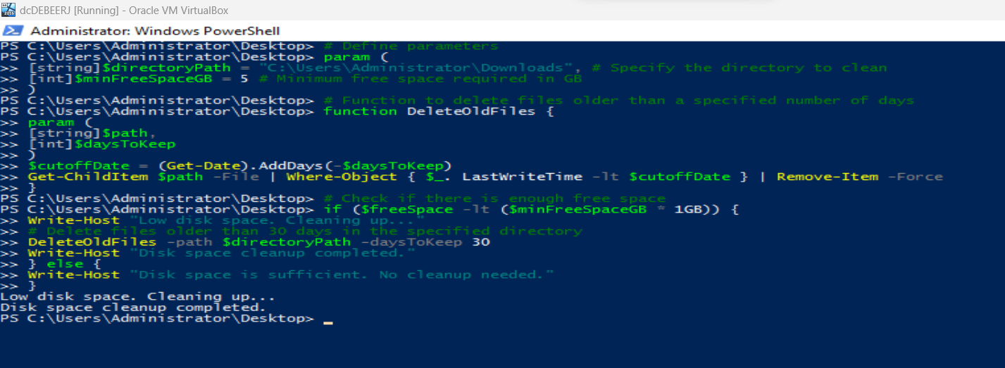

Figure 1 - Disk space cleanup script execution

## Parameters

# Define parameters

param (

[string]$directoryPath = "C:\Temp", # Specify the directory to clean

[int]$minFreeSpaceGB = 5 # Minimum free space required in GB

)

## Function

# Function to delete files older than a specified number of days

function DeleteOldFiles {

param (

[string]$path,

[int]$daysToKeep

)

$cutoffDate = (Get-Date).AddDays(-$daysToKeep)

Get-ChildItem $path -File | Where-Object { $_.LastWriteTime -lt $cutoffDate } | Remove-Item -Force

}

## Conditional

# Check if there is enough free space

$freeSpace = (Get-PSDrive -PSProvider FileSystem | Where-Object { $_.Root -eq $directoryPath }).Free

if ($freeSpace -lt ($minFreeSpaceGB * 1GB)) {

Write-Host "Low disk space. Cleaning up..."

## Loop

# Delete files older than 30 days in the specified directory

DeleteOldFiles -path $directoryPath -daysToKeep 30

Write-Host "Disk space cleanup completed."

} else {

Write-Host "Disk space is sufficient. No cleanup needed."

}

(sonalilotankar, 2023) (Microsoft Learn, n.d.)

# Service Status Check

Figure - Service status check execution to check Windows Update Service

## Parameters

# Define parameters

param (

[string]$serviceName = "wuauserv" # Specify the name of the service to check (Windows Update)

)

## Function

# Function to check and restart a Windows service

function CheckAndRestartService {

param (

[string]$service

)

## Conditional

$serviceStatus = Get-Service | Where-Object { $_.Name -like $service }

## Loop

if ($serviceStatus -ne $null) {

if ($serviceStatus.Status -ne "Running") {

Write-Host "$service is not running. Restarting..."

Restart-Service -Name $service

Write-Host "$service has been restarted."

} else {

Write-Host "$service is running."

}

} else {

Write-Host "Service '$service' not found."

}

}

# Check and restart the specified service (Windows Update)

CheckAndRestartService -service $serviceName

(Kardashevsky, 2023)

# References

Kardashevsky, C. (2023, February 8). *GET-SERVICE: CHECKING WINDOWS SERVICES STATUS WITH POWERSHELL*. Retrieved from The IT Bros: https://theitbros.com/get-service-powershell/#:~:text=You%20can%20use%20the%20Get,address%20as%20a%20computer%20name.

Microsoft Learn. (n.d.). *FileSystemProvider Class*. Retrieved from Microsoft Learn: https://learn.microsoft.com/en-us/dotnet/api/microsoft.powershell.commands.filesystemprovider?view=powershellsdk-7.3.0

sonalilotankar. (2023, August 24). *Disk Cleanup Using Powershell Scripts*. Retrieved from Geeks for Geeks: https://www.geeksforgeeks.org/disk-cleanup-using-powershell-scripts/